**IMPACTS OF DETERMINANTS TO ACCESS TO CREDIT IN KENYA (MOMBASA CASE)**

**BY**

**JOSEPH BAYA KARISA**

**SMSI/00815/2020**

**A PROJECT SUBMITTED IN PARTIAL FULFILMENT OF THE REQUIREMENTS FOR THE AWARD OF THE DEGREE OF BACHELOR OF TECHNOLOGY APPLIED STATISTICS**

**THE TECHNICAL UNIVERSITY OF KENYA**

**FACULTY OF APPLIED SCIENCES AND TECHNOLOGY**

**SCHOOL MATHEMATICS AND ACTUARIAL SCIENCE**

**DEPARTMENT OF STATISTICS AND COMPUTATIONAL MATHEMATICS**

**MARCH 2024**



ACKNOWLEGMENT

I am so grateful to God Almighty who has all the wisdom, knowledge and power for giving me health, determination and strength to move forward and complete my education.

DEDICATION

I am thankful for my parents' love and sacrifice, and I dedicate this research paper to them. Without the assistance of my colleagues and the school personnel, this would not be feasible. Working together fosters an atmosphere that values education, critical thinking, and the search for information.

Contents

:Introduction; 8

Rationale of the Study 12

Objectives of the study 13

Research Hypothesis 13

Model Specification; 14

Definition of Variables 16

ASSUMPTIONS OF LOGISTIC REGRESSION MODEL 18

Sample Size 19

Introduction 20

Introduction 21

Selecting relevant variables 22

###Checking for normality 23

Calculating correlation matrix 26

Extracting correlation coefficients and p-values 26

Selecting predictor variables 26

Building logistic regression model 26

Summary of the logistic regression model 27

Plot of predictor variables against log odds 29

Independence of observations 34

Plot of residuals against fitted values 34

Multicollinearity 35

Check for multicollinearity using Variance Inflation Factor (VIF) 35

Conclusion 36

Recommendations for Further Research 36

Limitations 37

LIST OF FIGURES

Figure 1 22

Figure 2 23

Figure 3 24

Figure 4 29

Figure 5 30

Figure 6 31

Figure 7 32

Figure 8 33

LIST OF TABLES

Table 1 15

Table 2 19

**CHAPTER 1: INTRODUCTION**

One of Kenya's main concerns is that financial institutions do not have enough capacity for startups. Access to finance remains an elusive goal for most Kenyans. Recent financial research shows that access to credit is a big problem, especially in regions.

Mwangi, I. W. (2010) listed various factors such as debtors' inability to provide accurate information about their financial situation, lack of reliability and basis of regular business and registration documents, ineffective appeal and recognition processes, corrupted courts and legal and judicial systems. These are the reasons why Kenya has banned access to bank loans. Other factors include significant financing costs, the business's distance from the nearest financial service provider, and demographic factors that reduce creditworthiness.

The practice of borrowing money from financial institutions using high interest rates excludes most of the poor because only large borrowers who need more money can afford the loan. High (Waari, D.N. and Mwangi, W.M. (2015)) can lead to unfavorable choices, as a result of which borrowers are often negatively affected by the use of debt instruments. Many people, especially those living in rural areas, rely on informal credit facilities. However, without full information about one's risk and eligibility, access to credit facilities from legal and illegal lenders is limited. The creation and operation of credit reporting agencies should change the credit environment, disseminate credit information and reduce information asymmetry. However, creating this organization is not enough because most of the resources and initial lenders are still unknown. Understanding each individual's specific demographic and health characteristics and their access to credit will help bridge the gap between why people are most concerned with finance and the context of expanding access to finance.

CHAPTER 2: LITERATURE Review

## **Introduction;**

Assuming a perfect economy, the fixed income model is the most useful model of mortgage loan demand (Mwangi, I.W. (2010)). On the other hand, institutional rigidities in the capital market are a feature of emerging nations, particularly low-income nations, which threaten the stability of the neoclassical notion of perfect competition, hard effort, and production mobility. Given the significant influence that schools have on business decision-making, it should come as no surprise that pipelines—which are intended to safeguard the impoverished from the effects of income fluctuations and to guard against instances of government overreach—play a significant role in security. There is a poor fit between jobs.

Another feature of financial markets in developing countries is widespread information asymmetry and weak mechanisms for managing contracts; This situation forces them to find other informal ways as a risk sharing process (Mwangi, I.W. and Sichei, M.M. (2011). For example, a person may receive financial support in the form of loans from relatives such as mother, father, spouse, children. Additionally, information about the cost of capital investment and its determinants can influence investment decisions. That's why people want to know the cost of investment options.

The concept of optimal capital markets proposed by Modigliani and Miller (1958) assumes that financial workers will spend more than they earn. Therefore, people can borrow to cover their current debts from future income, and income from financial institutions helps their behavior while encouraging investments.

Financial Order Hypothesis Munguti, J. M. (2013) suggests that finance meets the needs of employees in a hierarchical manner. They use existing funds first and then address debt and equity. Theoretically, this ranking is explained by the relative value of capital resulting from information asymmetry.

The credit gap results from the difference between borrowers who are willing and able to borrow. The margin is the result of certain lenders choosing to offer less than the market requires. Information asymmetry explains why financial institutions use loans.

Lenders are unable to differentiate between borrowers with varying levels of risk due to adverse selection in the credit markets. Consequently, instead of taking a chance on their investments, lenders choose to increase interest rates or require substantial collateral to protect themselves from default risk. But only large-scale borrowers with higher expectations of returns are drawn to this (Karanja, J., Mwangi, A., & Nyakarimi, S. (2014). Lenders set interest rates below market clearing rates yet restrict credit to reduce risk of loss since their priorities conflict with those of the borrowers. Research on information asymmetry has also been conducted by Adetoro, A. A., Ogundeji, A. A., Belle, J. A., and Ojo, T. O. (2021), It is advised to use non-price criteria for credit rationing.

Ongwech, W.L., Obel-Gor, C. and Otiende, M.A. (2020) argue that the relationship between financial institutions and firms also determines entry. Institutions with good relationships are expected to have greater access to credit. A relationship with a bank reduces risk and therefore the cost of the loan, that is, interest. This is because the nature of morality decreases and the stability of information increases, resulting in fewer negative choices.

The formation of informal financial institutions is a direct result of many deficiencies in receiving financial assistance from formal financial institutions. So people are returning to financial institutions where they have limited access to money. Most financial institutions, such as banks, view loans to poor families as dangerous and therefore impose many restrictions on them, requiring them to provide proof that they cannot afford it. Because their lives are poor, their attitudes towards eating are not good and their food average is very high. Kedir, A. (2003), this means that when given financial aid, they will first try to meet their basic needs before deciding how and where to invest. These challenges faced by the poor have led the international community to work to improve human health in line with the Millennium Development Goals to alleviate poverty and poverty. The Kenyan government is trying to close this gap by providing money to the poor through various channels through development banks. But. The target has not been reached yet.

The failure of established financial institutions to provide credit facilities has forced most people to find other ways of raising money from informal sources. Information asymmetries reduce information about how and where money can most easily be accessed. Agriculture, the backbone of Kenya's economy, has been hardest hit as farmers have been unable to access finance, production has declined and many have turned to small businesses that are more profitable than agriculture.

Fatoki, O. and Odeyemi (2010) A.: An examination of credit management and recovery in small enterprises using data from financial institutions in South Africa. To ascertain the relationship between and impact on life, several characteristics are analyzed, including age, balance, relationship (personal, commercial, and new customers), interest rate, loan amount, loan maturity, product type, size, gender, and race. Because the variables (presets) are binary in form, binary logit models are used by researchers to assess the impact and accuracy of reimbursement decisions. 169 small company loans from South African banks were investigated for this study. According to the data, 28% of loans had arrears and 39% had not been repaid on time. The study's findings indicate that if small and medium-sized businesses obtain greater loans, and they ought to have large capital or deposits. In the banking sector, banks are more inclined to lower fees the more deposits their clients make.

Higher deposits reduce the loss during operation, while lower losses mean less amount will be written off by the bank in case of default. This also reduces risk for the borrower and lender, thus increasing the likelihood of cost reduction as banks do not need to seek as much credit.

Lending occurs due to the difference between borrowers who are willing and able to borrow. Olorade, R.A. and F. Olagunju I. (2013) argues that the lines drawn by certain lenders choose to provide less than the needs of the economy. Information asymmetry explains why financial institutions use loans.

With the collapse of the Agricultural Development Corporation (ADC) in the late eighties, agriculture declined as the government reduced its commitment to encouraging farmers in the provision and sale of agricultural products. This phenomenon will continue until the microfinance institution plays a role in increasing productivity. Today, most of the prerequisites have been relaxed and many people can access money even without any obligations. In addition, financial aid will be provided to people for agricultural products such as milk.

Intense competition among financial institutions in Kenya has forced banks to adopt door-to-door marketing schemes to promote their products to retain their reach and remain relevant. As the world turns its attention to disadvantaged groups in society, it is a warning to mainstream financial institutions to be careful or risk being forced out of the market. International organizations have also publicly announced that they are ready to work only with people involved in providing grants to small groups.

## **Rationale of the Study**

Despite the fact that having access to credit promotes business, research indicates that credit rationing keeps most individuals out of the workforce, particularly the impoverished. This is a crucial subject for investment and personal recovery. The majority of adult Kenyans do not have access to credit, according to KNBS. Furthermore, relatively few people are able to use unlicensed credit services. A campaign was started by Vision 2030 to bring the percentage of adult unemployed people down to less than 70%. Most impoverished people are not able to borrow money from financial institutions at high interest rates since only large borrowers with larger repayment obligations can afford these rates (Kedir, A. (2003)). Lenders frequently decline to employ interest-based loans, acting as both borrowers and lenders. Many individuals, particularly in rural areas, depend on retailers and farmers are examples of unofficial suppliers of buyers and sellers. However, access to credit facilities from both legal and illegitimate lenders is restricted in the absence of complete information about one's risk and eligibility.

Understanding personal demographics and health characteristics can help reduce risk. Information asymmetries characterize lending and borrowing and run deep. This will lead to smoothing of use and increased investment. Additionally, the Central Bank of Kenya (CBK) can use such information to implement reforms aimed at improving and improving the financial sector. It will also remove barriers to further investment, thus encouraging people to benefit from investment and ultimately improve their living conditions. Through a better understanding of individual characteristics, financial institutions can design products to suit people's different needs, rather than focusing on credit rationing to lower the original price.

## **Objectives of the study**

The general objective of this study is to establish the factors which determine individual access to credit in Kenya (Mombasa County).

The specific Objectives are:

1. To establish factors that enhances and those that limit individual access to credit in Mombasa County.
2. To draw policy implications and make regarding recommendations access to credit in Mombasa County.

## **Research Hypothesis**

Ho; There is no relationship between the factors and access to credit by Households in Mombasa County.

**CHAPTER 3: MethodOLOGY**

## **Model Specification**;

The determinants of credit availability were examined in this study using logit regression models. This method was selected due to the result variable's discrete dichotomous nature, which is a household's access to credit status.

Logistic Regression

In a logit regression model, the probability, p, that a household sought and accesses credit is given by

$P={e^{z}}/{1+ e^{z}}$

The odds ratio: this is basically the probability of soughting and accessing credit over soughting and not accessing credit

Odds= $\frac{1}{1 - P}$

When the logs of odd are taken then it’s transformed to the linear combination of the predictors in the regression model.

Logit $\left(p\right)=Log \left(\frac{P}{1 - P}\right)=β_{0}+β_{1}X_{1}+β_{2}X_{2}+....+β_{n}X_{n}+ε$

Borrowing from Menard, S. (2002) and assuming that the probability of soughting and accessing to credit or having no access is determined by an underlying response variable that captures the true economic status of a household, then central to the use of logit regression is the logit transformation of p given by Z which is specified as below;

$Z_{i}=α+βX_{i }+ε_{i}$

Where X is a set of independent variables, is a vector of regression parameters to be estimated and $ε$ is a random error term.

In modeling determinants of soughting and having access to credit, this study assumed that the dependent variable $\left(Z\right)$. There are two levels namely soughting and accessing credit =1 and soughting and not accessing credit = 0.

The study estimated the following model:

$Z= α+β_{1}age+β_{2}sought credit+β_{3}household income+ε$

Hence for multiple variables,

$P=\frac{1}{1+ e^{-\left(β_{0}+β_{1}X_{1}+β_{2}X_{2}+..+β_{n}X_{n}\right)}}$

The log-odds (logit) form of the logistic regression equation is

$Logit\left(P\right)=Log\left(\frac{p}{1 - p}\right)=β_{0}+β_{1}X_{1}+β_{2}X_{2}+....+β_{n}X_{n}+ε$

In this form, the logistic regression model linearly combines the predictor variables with their associated coefficients and then transforms the result using the logistic function to obtain probabilities.

The logistic function (sigmoid function) is defined as

$logistic \left(x\right)=\frac{1}{1+e^{x}}$

This function ensures that the predicted probabilities lie between 0 and 1, making it suitable for binary classification.

## **Definition of Variables**

Table 1

|  |  |
| --- | --- |
| Variable | Operational Measure |
| Age of Household | = 1 if household age is 19-65 years =0 if otherwise |
| Household income | Incomed earned in Kshs per month |
| Sought credit | Sought credit =1 if yes  Did not sought credit = 0 if No |
| Sought and accessed credit | Sought and accessed credit = 1 if yes  Sought and not accessed credit =0 if no |
| Education of Household | If Tertiary =1  Otherwise = 0 |
| Number of Children | numbers |

Description of Variables

Dependent Variables.

Sought and accessed to credit. The dependent variable sought and access to credit can assume two values if yes=1 and no=0.

Independent Variables

Household income

The amount of loan a family receives usually depends on its income. Households with higher incomes may qualify for larger loans, giving them more flexibility in financing a variety of purposes. Lenders often evaluate a family's creditworthiness based on their income. A higher household income generally indicates a greater ability to repay the loan, which increases the household's ability to obtain a loan. A stable and higher income proves to lenders that the family has the financial strength to meet its repayment obligations, thus gaining loan approval. High-income households have access to a variety of credit products, including personal loans, home loans and business loans. This diversity allows them to meet a variety of financial needs.

Household Age

An extended credit history can be favorable for older households when asking for loans. A clean credit history shows a history of responsible borrowing and loan payments. Elderly households frequently have more stable finances and a higher level of financial management knowledge. These households might be seen by lenders as lower risk, which would facilitate their access to loans. Age might bring about changes in a household's financial objectives. Elderly households may apply for credit for a variety of reasons, including home upgrades, medical costs, or providing for their adult children. Lenders may take these objectives into account when assessing accounts. It's possible that older households have more assets than younger ones, and these assets can be utilized as loan collateral. This improves their creditworthiness and raises the possibility that they will be granted credit.

Household Level of Education

Lenders evaluate a household's creditworthiness based on the educational attainment of its members. Higher education levels may be linked to steady work and income, which helps lenders see you favorably. Greater financial literacy is frequently correlated with higher educational attainment. A household is more likely to successfully complete the credit application procedure if members have a greater awareness of financial concepts and management. Households with higher levels of education might be more knowledgeable about the range of credit products available as well as the advantages and disadvantages of borrowing. Their ability to make educated decisions regarding obtaining credit may be enhanced by this knowledge. Education and employment prospects are frequently correlated. Higher educated households might have individuals in more profitable and secure jobs, which would improve their creditworthiness.

Household Number of Children

Bigger families with more kids can have to set aside a larger percentage of their income for necessities like daily costs, healthcare, and education. This distribution may have an impact on the discretionary income available for loan repayments, which may have an impact on credit availability. A household's spending habits may be impacted by the expenditures of raising children, particularly educational expenses. Lenders may take these trends into account when determining whether a household can afford to take on more debt.

## **ASSUMPTIONS OF LOGISTIC REGRESSION MODEL**

1. BINARY OUTCOME

The dependent variable ought to reflect two outcomes and be binary or dichotomous.

1. INDEPENDENCE OF OBSERVATIONS

The observations ought to stand alone from one another. This implies that one observation's result shouldn't be impacted by the result of another observation.

1. LINEARITY OF THE LOGIT

There must be a relationship between the different wheels of freedom and progress. In other words, the resultant of the variance must be the natural logarithm of the variance of the variance.

1. NO MULTICOLLINEARITY

The independent variables should have minimal to no multicollinearity. When two or more independent variables have a strong correlation with one another, it's known as multicollinearity and can be challenging to distinguish between each variable's unique impact on the dependent variable.

1. LARGE SAMPLE SIZE

For statistical regression to yield consistent results, a sizable sample size is usually necessary. It is generally recommended that each predictor variable have at least 10–20 observations.

## **Sample Size**

The research is predicated on data from the 2019 Kenya National Bureau of Statistics (KNBS) Population and Housing Census.

The survey focused on 6,343 (2019) respondents who were older than 18, which is Kenya's current legal age limit for obtaining an ID card. People under the age of 16 were not looked at because it is believed that they are not mature enough to decide for themselves where to get credit services.

The homes were chosen at random from both rural and urban groups across the nation. Afterwards, respondents were chosen from those households to provide feedback on a range of financial issues.

**CHAPTER 4:DATA ANALYSIS AND INTERPRETATION OF RESULTS**

## **Introduction**

The study's conclusions and their interpretation are presented in this chapter.   
The sample's descriptive statistics:   
This paper's study is predicated on a sample of 118 homes.

Table 2

|  |  |  |
| --- | --- | --- |
| Variable | Mean | Standard deviation |
| Sought and Accessed Credit (1= yes) | 0.3898305 | 0.4897915 |
| Sought Credit (1=yes) | 0.8644068 | 0.343816 |
| Age of Household (years) | 38.45763 | 8.534139 |
| Household Income (Kshs) | 84449.15 | 33870.88 |
| Education Of Household ( 1= tertiary) | 0.7966102 | 0.4042366 |
| Household Number of Children ( numbers) | 0.6355932 | 0.8931387 |

# Introduction

This is the analysis of my project impacts of determinants of access to credit in Kenya Mombasa case.

[1] "C:/Users/JOSEPH BAYA/Desktop"

# A tibble: 6 × 10  
 `HOUSEHOLD NO` COUNTY `SUB-COUNTY` `COUNTY WARD` `NUMBER OF CHILDREN`  
 <dbl> <chr> <chr> <chr> <dbl>  
 1 1 Mombasa County Changamwe Su… Airport Ward 0  
 2 2 Mombasa County Changamwe Su… Chaani Ward 2  
3 3 Mombasa County Changamwe Su… Changamwe Wa… 1  
 4 4 Mombasa County Changamwe Su… Port Reitz W… 0  
 5 5 Mombasa County Changamwe Su… Airport Ward 3  
 6 6 Mombasa County Changamwe Su… Chaani Ward 0  
 # ℹ 5 more variables: `SOUGHT CREDIT` <chr>,  
 # `SOUGHT CREDIT AND ACCESSED CREDIT` <chr>, `HOUSEHOLD INCOME` <dbl>,  
 # Age <dbl>, Education <chr>

HOUSEHOLD NO COUNTY SUB-COUNTY COUNTY WARD   
 Min. : 1.00 Length:118 Length:118 Length:118   
 1st Qu.: 30.25 Class :character Class :character Class :character   
 Median : 59.50 Mode :character Mode :character Mode :character   
 Mean : 59.50   
 3rd Qu.: 88.75   
 Max. :118.00   
 NUMBER OF CHILDREN SOUGHT CREDIT SOUGHT CREDIT AND ACCESSED CREDIT  
 Min. :0.0000 Length:118 Length:118   
 1st Qu.:0.0000 Class :character Class :character   
 Median :0.0000 Mode :character Mode :character   
 Mean :0.6356   
 3rd Qu.:1.0000   
 Max. :3.0000   
 HOUSEHOLD INCOME Age Education   
 Min. : 25000 Min. :25.00 Length:118   
 1st Qu.: 57500 1st Qu.:31.00 Class :character   
 Median : 85000 Median :38.00 Mode :character   
 Mean : 84449 Mean :38.46   
 3rd Qu.:108750 3rd Qu.:46.00   
 Max. :162500 Max. :53.00

# Selecting relevant variables

[1] "HOUSEHOLD NO" "COUNTY"   
 [3] "SUB-COUNTY" "COUNTY WARD"   
 [5] "NUMBER OF CHILDREN" "SOUGHT CREDIT"   
 [7] "SOUGHT CREDIT AND ACCESSED CREDIT" "HOUSEHOLD INCOME"   
 [9] "Age" "Education"

###Checking for normality 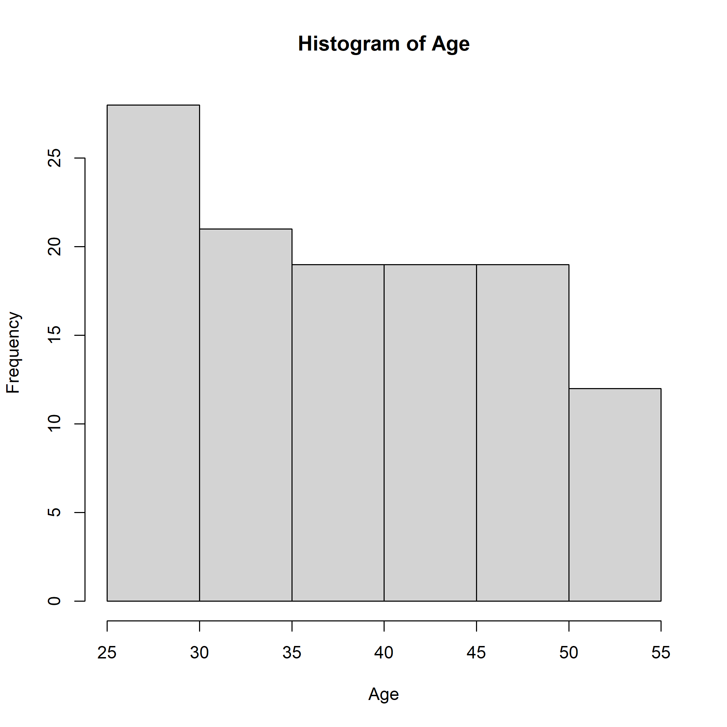

Figure 1

uniform distribution, where each value has an equal likelihood of occurring.

The data is spread due to presence of wide bars

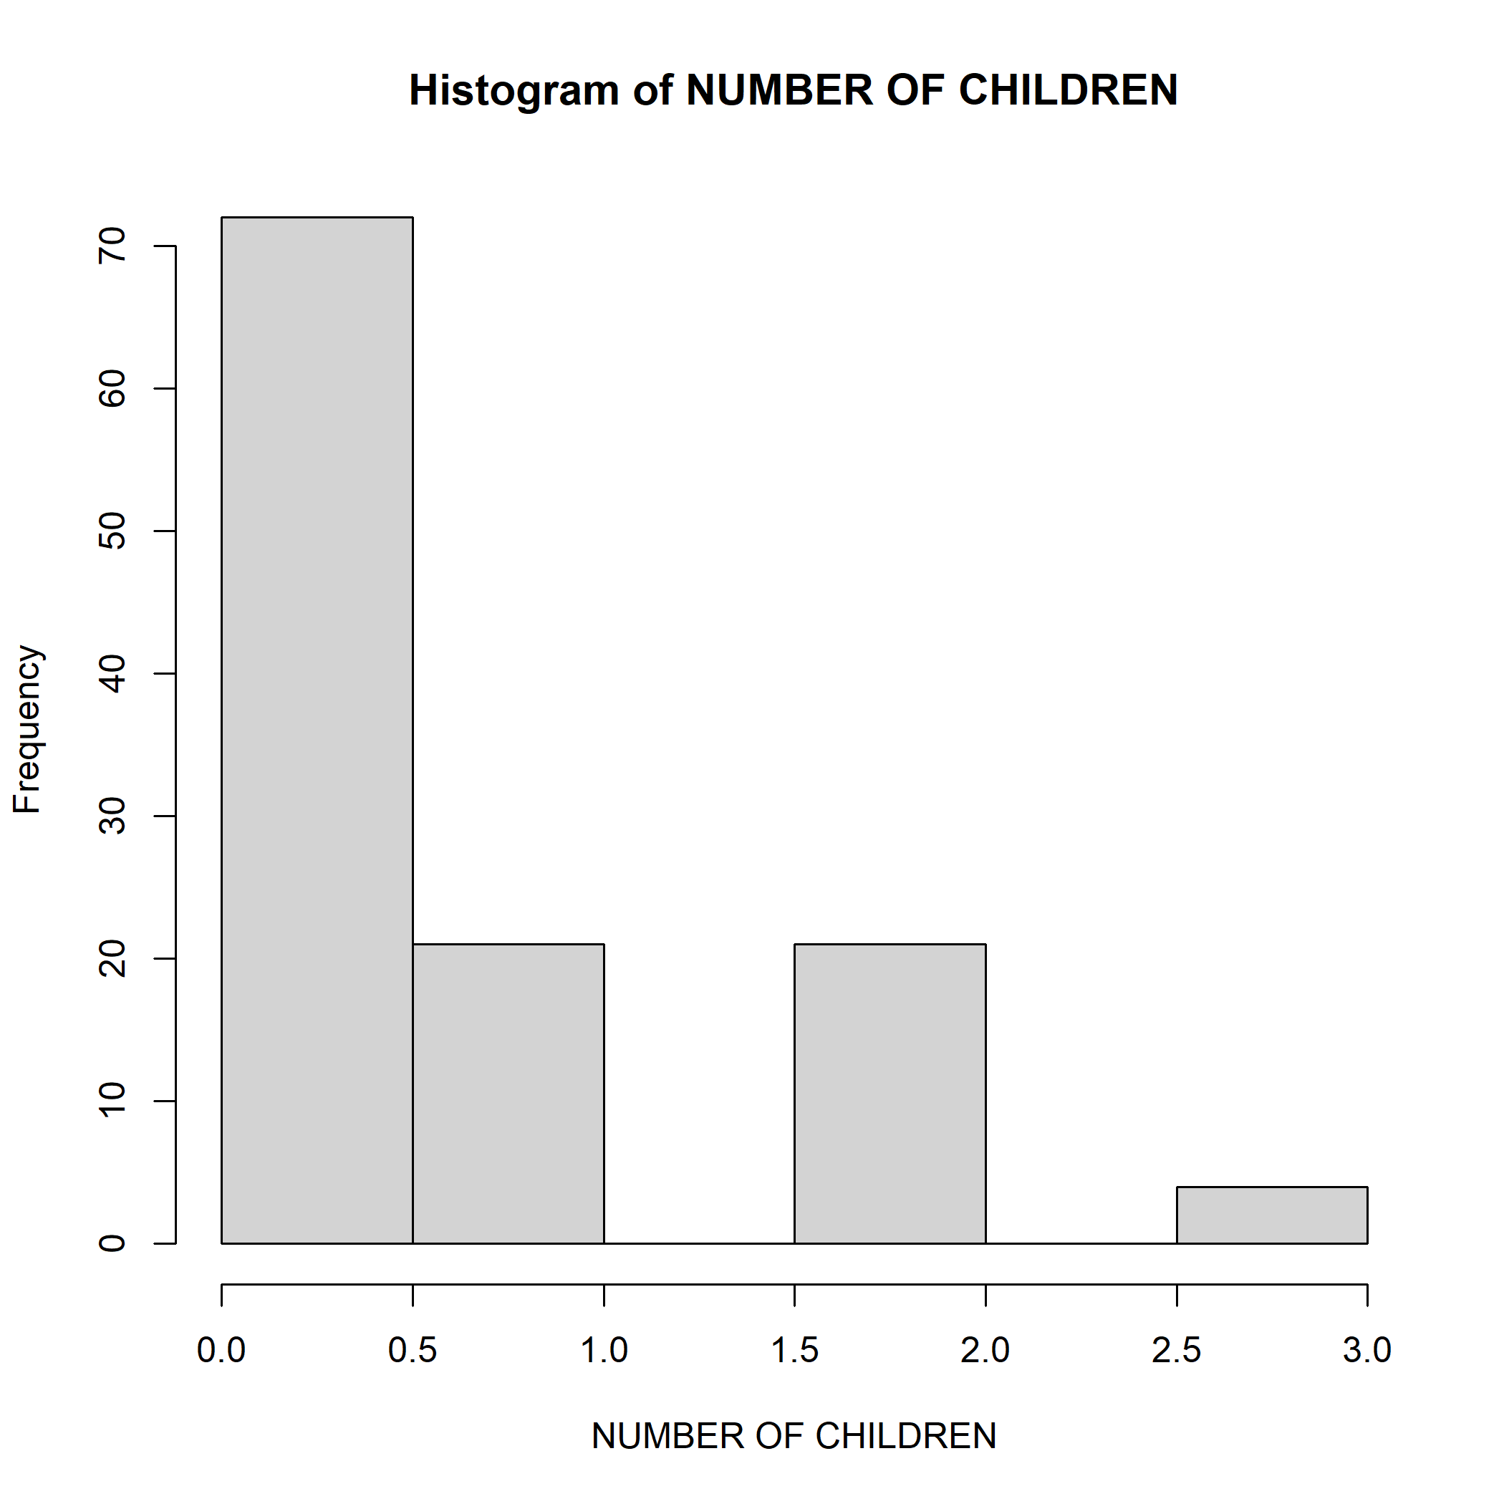

Figure 2

The number of children is not uniform across the households

Figure 3

Shapiro-Wilk normality test  
   
 data: transformed_data  
 W = 0.70837, p-value = 5.35e-14

# The small p-value provides evidence to reject the null hypothesis.

With such a low p-value, there is strong evidence to conclude that the data does not follow a normal distribution.

## Calculating correlation matrix

# Extracting correlation coefficients and p-values

[1] 0.02852273

[1] 1.494801e-79

Coefficients = 0.02852273 Within this framework, the correlation coefficient serves as a statistical metric that elucidates the linear relationship between two variables. An indication of a modest positive linear link between the two variables is the correlation coefficient of 0.0285 between ‘R’ and ‘Age’. An increasing value of one variable (in this case, ‘R’) is correlated with an increasing value of the other variable (in this case, ‘Age’). The value of 0.0285, however, is quite near to zero, suggesting that there is little correlation between “R” and “Age.” In conclusion, the relationship between “R” and “Age” is good, however it is not very strong.

P Value = 1.494801e-79 To put it simply, the p-value is a figure that indicates whether or not group differences in a study are statistically significant. The p-value in this instance, 1.494801e-79, is incredibly tiny—nearly zero—and suggests compelling evidence that the groups under comparison are not different from one another. Therefore, based on this extremely small p-value, we can conclude that there is a significant difference in the average values of ‘R’ for different age groups.

# Selecting predictor variables

## Building logistic regression model

Call:  
 glm(formula = R ~ ., family = binomial, data = Z %>% select(R,   
 all_of(predictor_vars)))  
   
 Coefficients:  
 Estimate Std. Error z value Pr(>|z|)   
 (Intercept) -1.802e+01 1.518e+03 -0.012 0.9905   
 `HOUSEHOLD NO` -8.282e-03 6.331e-03 -1.308 0.1908   
 EducationDoctorate 1.366e+00 7.015e-01 1.947 0.0516 .  
 EducationHigh School Certificate 5.818e-02 5.440e-01 0.107 0.9148   
 EducationMaster's Degree -8.509e-01 6.258e-01 -1.360 0.0139   
 Age -3.823e-02 3.843e-02 -0.995 0.3198   
 `SOUGHT CREDIT`Yes 1.873e+01 1.518e+03 0.012 0.9902   
 `HOUSEHOLD INCOME` 1.186e-05 1.006e-05 1.179 0.0283   
 ---  
 Signif. codes: 0 '***' 0.001 '**' 0.01 '*' 0.05 '.' 0.1 ' ' 1  
   
 (Dispersion parameter for binomial family taken to be 1)  
   
 Null deviance: 157.81 on 117 degrees of freedom  
 Residual deviance: 130.43 on 110 degrees of freedom  
 AIC: 146.43

Number of Fisher Scoring iterations: 17

## Summary of the logistic regression model

Call:  
 glm(formula = R ~ ., family = binomial, data = Z %>% select(R,   
 all_of(predictor_vars)))  
   
 Coefficients:  
 Estimate Std. Error z value Pr(>|z|)   
 (Intercept) -1.802e+01 1.518e+03 -0.012 0.9905   
 `HOUSEHOLD NO` -8.282e-03 6.331e-03 -1.308 0.1908   
 EducationDoctorate 1.366e+00 7.015e-01 1.947 0.0516 .  
 EducationHigh School Certificate 5.818e-02 5.440e-01 0.107 0.9148   
 EducationMaster's Degree -8.509e-01 6.258e-01 -1.360 0.0139   
 Age -3.823e-02 3.843e-02 -0.995 0.3198   
 `SOUGHT CREDIT`Yes 1.873e+01 1.518e+03 0.012 0.9902   
 `HOUSEHOLD INCOME` 1.186e-05 1.006e-05 1.179 0.0283   
 ---  
 Signif. codes: 0 '***' 0.001 '**' 0.01 '*' 0.05 '.' 0.1 ' ' 1  
   
 (Dispersion parameter for binomial family taken to be 1)  
   
 Null deviance: 157.81 on 117 degrees of freedom  
 Residual deviance: 130.43 on 110 degrees of freedom  
 AIC: 146.43  
   
 Number of Fisher Scoring iterations: 17

The binary response variable ‘R’ and a number of predictor factors were compared using logistic regression analysis. The following are the outcomes:

Intercept The intercept did not reach statistical significance, indicating that, when all other predictors are kept constant, the log-odds of ‘R’ do not deviate substantially from zero.

HOUSEHOLD NO The log-odds of ‘R’ are negatively impacted by this variable in a non-significant way.

Levels of Education The log-odds of ‘R’ exhibit a slightly significant positive correlation with ‘Education Doctorate’. - “Education Master’s Degree” and “Education High School Certificate” have no real bearing.

Age The log-odds of ‘R’ are not much impacted by age.

Sought Credit Yes There is no statistical significance for this variable.

HOUSEHOLD INCOME The log-odds of ‘R’ exhibit a positive correlation with ‘HOUSEHOLD INCOME’.

AIC and deviance statistics are used to evaluate the overall model fit, and coefficient estimates, standard errors, z- and p-values are also included in the interpretation.

The dispersion parameter for the binomial family was taken to be 1.

In conclusion, the results of the logistic regression analysis indicate that the outcome variable R may be significantly predicted by both household income and possessing a master’s degree in education. There is no discernible effect of other model variables on R. The model does a good job of fitting the data.

## Plot of predictor variables against log odds

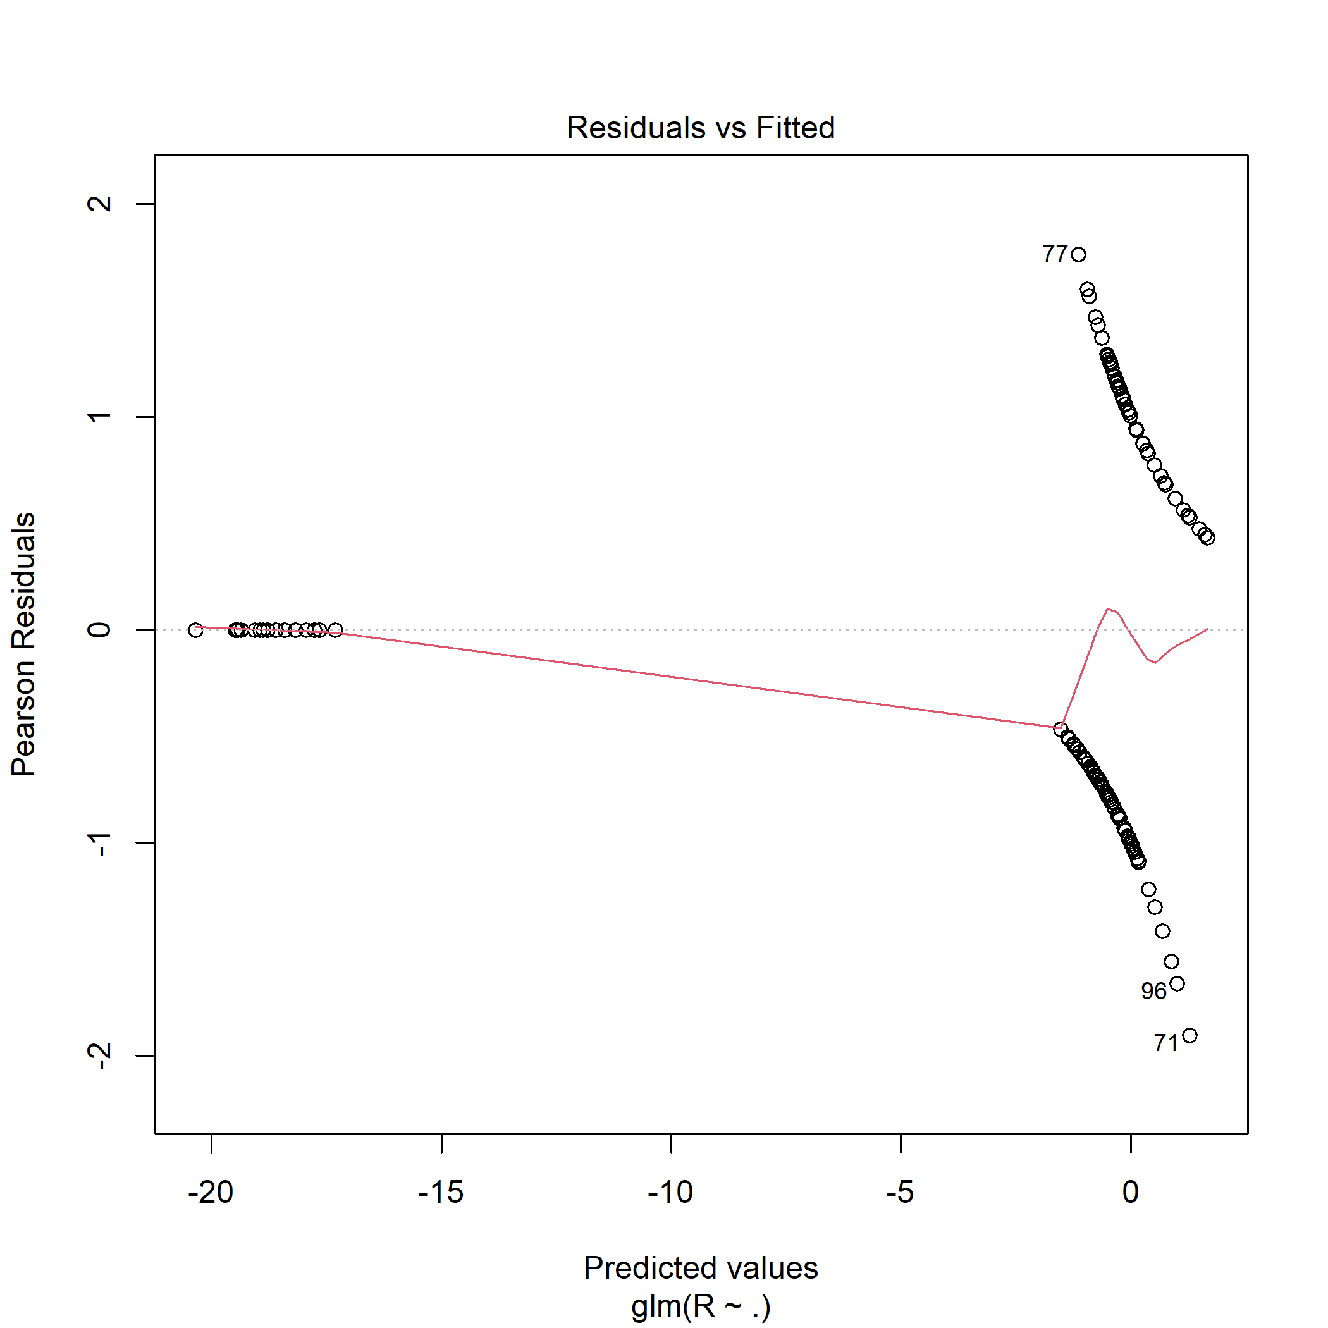

Figure 4

Residuals are not evenly spread across all fitted values

Residuals form a random scatter around the horizontal line at 0.

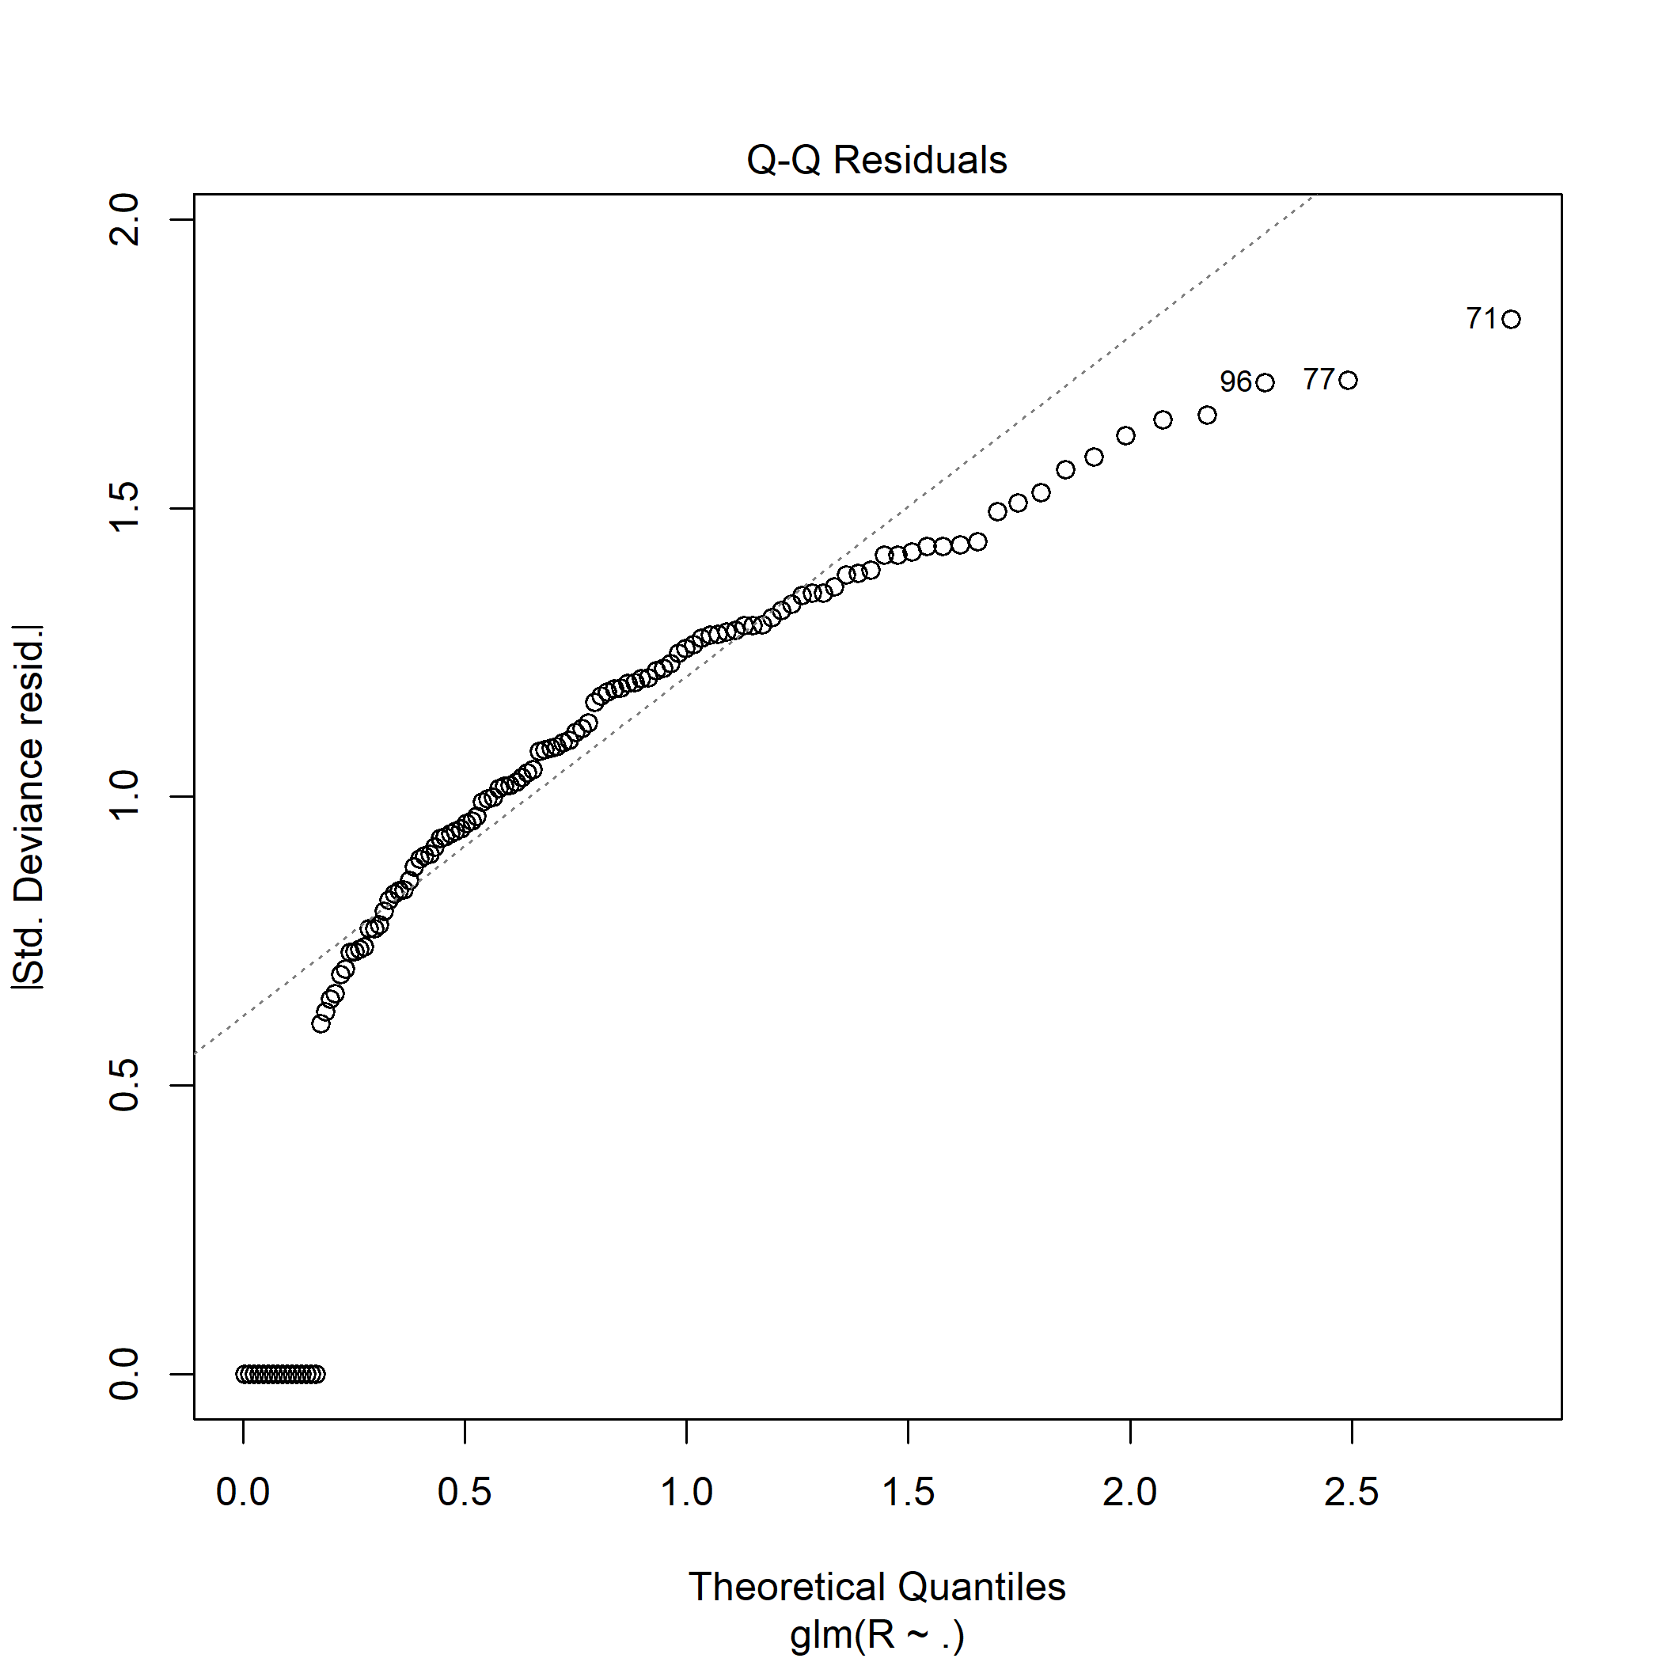

Figure 5

The points closely follow the 45-degree reference line, suggesting that the residuals are well-behaved and approximately normally distributed. This indicates that the assumptions of normality for regression residuals are met.

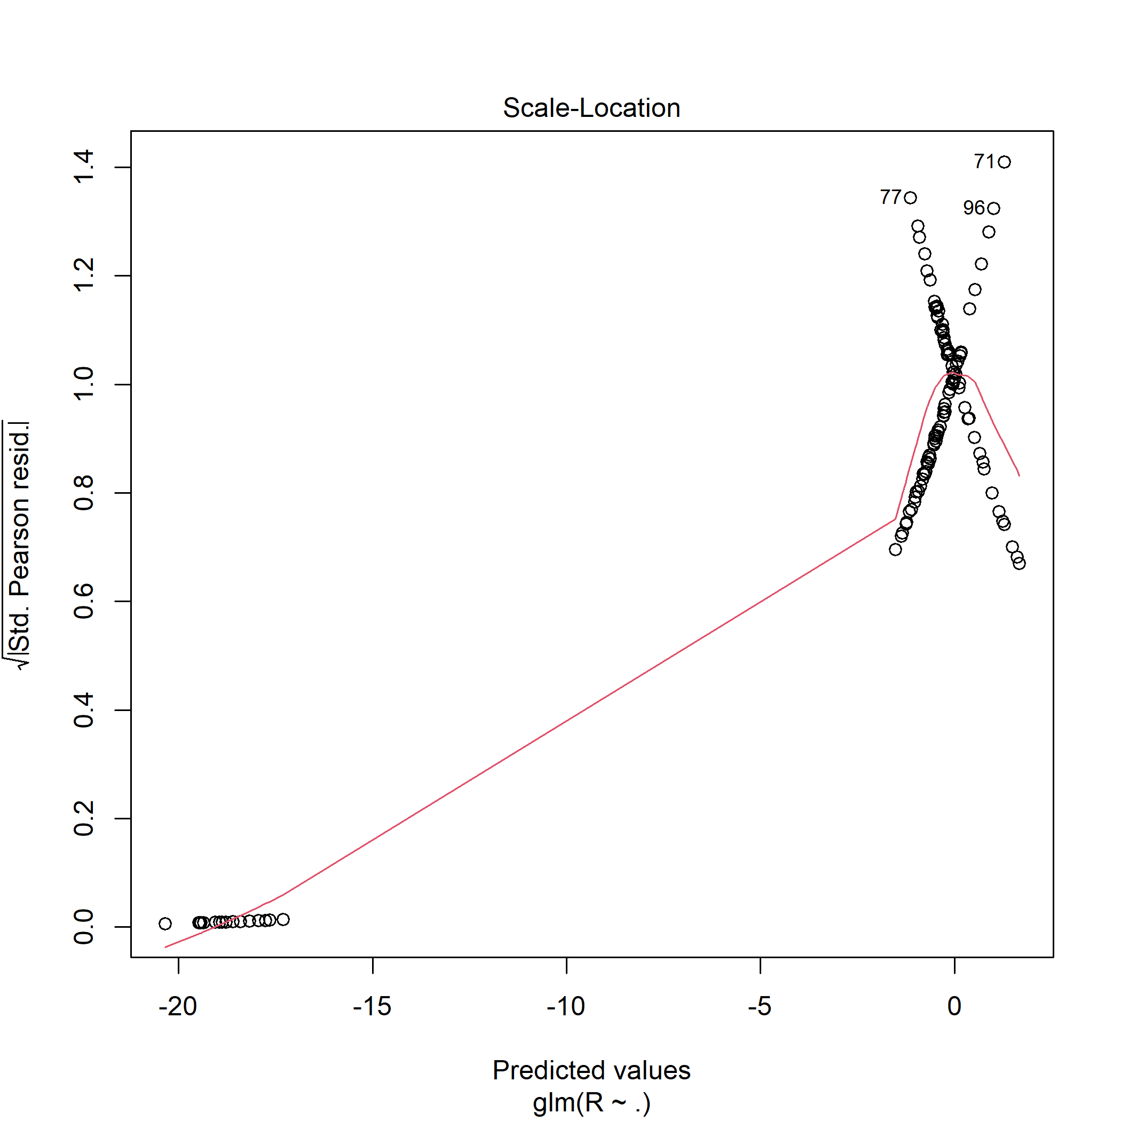

Figure 6

Scattering of points around a horizontal line, indicating that the spread of residuals is constant across all levels of fitted values.

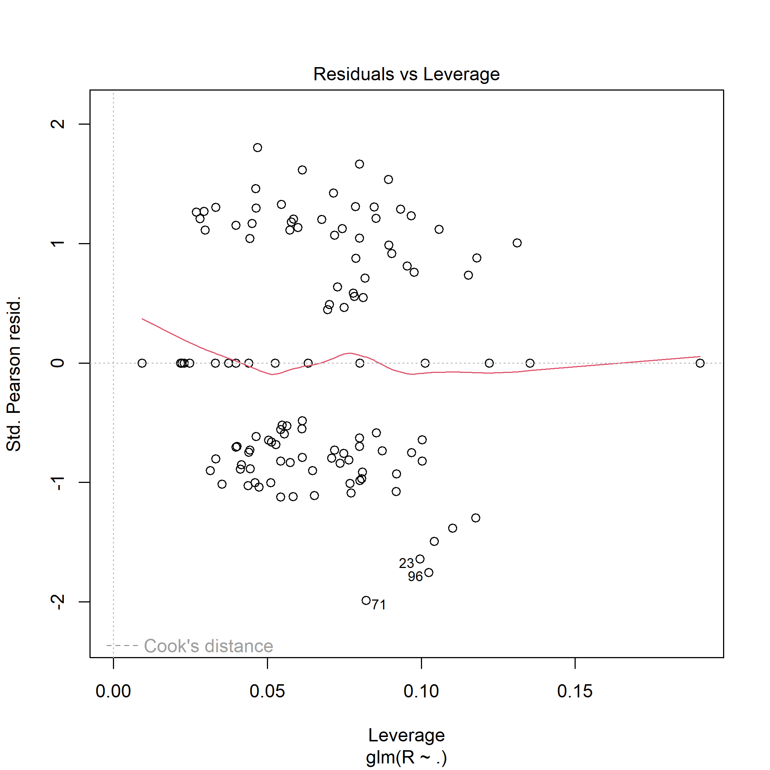

Figure 7

Presence of outliers in the data since points with high standardized residuals (far from 0 on the vertical axis) are potential outliers.

Outliers with both high residuals and high leverage values, especially outside the Cook's Distance contours, may have a disproportionate impact on the model.

## Independence of observations

# Plot of residuals against fitted values



Figure 8

There’s presence of outliers.

While the model generally fits well, there are a few areas with increased variability in residuals.

While the majority of residuals are well-distributed, there is a slight funnel shape in the plot, indicating a potential increase in variability at higher fitted values.

The Normal Q-Q Plot visually assesses the normality assumption of a dataset. In the plot, most data points closely align with the reference line, indicating adherence to normality, particularly in the middle range. However, deviations at both ends suggest potential skewness or outliers. Overall, the dataset appears approximately normally distributed, but further analysis, such as statistical tests or transformations, may be necessary to confirm adherence to the normal distribution assumption.

In Residuals vs fitted plot, here's a clear curvature or systematic shape hence indicating that the model doesn't capture the underlying relationship adequately.

## Multicollinearity

# Check for multicollinearity using Variance Inflation Factor (VIF)

GVIF Df GVIF^(1/(2*Df))  
 `HOUSEHOLD NO` 1.013754 1 1.006854  
 Education 1.418734 3 1.060027  
 Age 2.590697 1 1.609564  
 `SOUGHT CREDIT` 1.000000 1 1.000000  
 `HOUSEHOLD INCOME` 2.820461 1 1.679423

HOUSEHOLD NO The GVIF for HOUSEHOLD NO is close to 1, indicating low multicollinearity. There is no significant inflation of variance for this predictor.

Education The GVIF for ‘Education’ is moderate, suggesting some level of collinearity among the education-related predictor variables. However, the inflation factor is not excessively high.

Age The GVIF for ‘Age’ is higher, indicating a moderate level of collinearity. The predictor ‘Age’ is associated with a higher inflation factor compared to other variables.

SOUGHT CREDIT: The GVIF for SOUGHT CREDIT is exactly 1, indicating no multicollinearity.

HOUSEHOLD INCOME: The GVIF for HOUSEHOLD INCOME is higher, suggesting a moderate level of collinearity.

In conclusion, less multicollinearity exists between the variables in a regression model when the GVIF value is lower (close to 1). Conversely, greater GVIF values imply a larger degree of collinearity between the variables.

CHAPTER 5: CONLUSIONS AND RECOMMENDATIONS

## Conclusion

Based on the data, we find that Approximately 38.98% of households sought and accessed credit while 61.02% of the total sampled population were found to be credit constrained. However, 86.44% of household sought credit. About 79.66% of households have tertiary education and on average, households have approximately one child.

Educational attainment and household income levels exhibited statistically meaningful impacts on credit accessibility. Specifically, individuals with higher levels of education and greater household incomes were more likely to secure credit.

Age demonstrated a moderate effect, suggesting that while age plays a role in credit access, its influence is not overwhelming.

Certain variables, such as whether an individual had sought credit, did not exert significant effects on credit accessibility.

The logistic regression model employed, as evidenced by the deviance statistics, provided a reasonable fit for the data, thereby establishing a foundation for comprehending the relationship between the selected determinants and the ability to access credit.

## Recommendations for Further Research

Even though the current analysis clarifies a number of issues, more investigation may uncover more plausible factors affecting credit availability. Furthermore, more detailed insights might be obtained by delving deeper into the subtleties of age groups, income brackets, and educational backgrounds.

The findings suggest that educational attainment and household income play crucial roles in determining credit access. Policymakers and financial institutions can leverage this information to tailor their strategies and services, potentially improving access to credit for a broader demographic.

## Limitations

The use of secondary data may have restricted the variables' range, making it more difficult to capture the impacts of determinants of access to credit. Furthermore, the outcomes might have been impacted by biases that existed during the data collection procedure. Furthermore, the findings' limited application to different groups may have resulted from a lack of diversity caused by the incomplete and unreliable information on the samples. Therefore, in order to further examine the determinants of access to credit, future study should concentrate on collecting primary data.

Reference

Waari, D. N., & Mwangi, W. M. (2015). Factors influencing access to finance by micro, small and medium enterprises in Meru County, Kenya. *International Journal of Economics, Commerce and Management*, *3*(4), 1-15. <https://citeseerx.ist.psu.edu/document?repid=rep1&type=pdf&doi=75865c597f4920ff808b8f3826249eef58696186>

Kiplimo, J. C., Ngenoh, E., Koech, W., & Bett, J. K. (2015). Determinants of access to credit financial services by smallholder farmers in Kenya. *Journal of Development and Agricultural Economics*, *7*(9), 303-313. <https://academicjournals.org/journal/JDAE/article-full-text-pdf/202861454984>

Mwangi, I. W., & Sichei, M. M. (2011). Determinants of access to credit by individuals in Kenya: A comparative analysis of the Kenya National FinAccess Surveys of 2006 and 2009. *European Journal of Business and Management*, *3*(3), 206-227. <https://core.ac.uk/download/pdf/234624035.pdf>

Mwangi, I. W. (2010). *Determinants of access to credit by individuals in Kenya* (Doctoral dissertation, University of Nairobi, Kenya). <http://erepository.uonbi.ac.ke/handle/11295/5138>

Kiplimo, J. C., Ngenoh, E., Egerton, K., & Bett, J. K. (2015). Evaluation of factors influencing access to credit financial services: evidence from smallholder farmers in eastern region of Kenya. *Evaluation*, *6*(17), 1-11. <https://www.carijournals.org/journals/index.php/IJF/article/view/164>

Ongwech, W. L., Obel-Gor, C., & Otiende, M. A. (2020). Determinants of credit access among smallholder dairy farmers in Kinangop sub-county, Kenya. <http://197.136.17.126/handle/123456789/520>

Karanja, J., Mwangi, A., & Nyakarimi, S. (2014). Analysis of factors influencing access to credit services by women entrepreneurs in Kenya. *Research Journal of Finance and Accounting*, *5*(11). <https://papers.ssrn.com/sol3/papers.cfm?abstract_id=2493114>

Munguti, J. M. (2013). Determinants of Micro Credit Performance in Microfinances in Kenya. *Unpublished Master of Business Admiministration (Finance Option) Thesis: Kenyatta University*. <http://ir-library.ku.ac.ke/bitstream/handle/123456789/10127/Determinants%20of%20Micro%20Credit%20Performance%20in%20Microfinances%20in%20Kenya.pdf?sequence=1>

Ojo, T. O., Adetoro, A. A., Ogundeji, A. A., & Belle, J. A. (2021). Quantifying the determinants of climate change adaptation strategies and farmers' access to credit in South Africa. *Science of the Total Environment*, *792*, 148499. <https://www.sciencedirect.com/science/article/pii/S0048969721035713>

Fatoki, O., & Odeyemi, A. (2010). The determinants of access to trade credit by new SMEs in South Africa. *African Journal of Business Management*, *4*(13), 2763. <https://academicjournals.org/journal/AJBM/article-full-text-pdf/1963C1C24144>

Ololade, R. A., & Olagunju, F. I. (2013). Determinants of access to credit among rural farmers in Oyo State, Nigeria. *Global Journal of Science Frontier Research Agriculture and Veterinary Sciences*, *13*(2), 16-22. <https://www.researchgate.net/profile/Rachel-Ololade-2/publication/327058053_Ololade_RA_and_Olagunju_FI_2013_Determinants_of_Access_to_Credit_among_Rural_Farmers_in_Oyo_State_Nigeria_Global_Journal_of_Science_Frontier_Research_D_13217-22/links/5b768cad92851ca650653ac9/Ololade-RA-and-Olagunju-FI-2013-Determinants-of-Access-to-Credit-among-Rural-Farmers-in-Oyo-State-Nigeria-Global-Journal-of-Science-Frontier-Research-D-132-17-22.pdf>

Assogba, P. N., Kokoye, S. E. H., Yegbemey, R. N., Djenontin, J. A., Tassou, Z., Pardoe, J., & Yabi, J. A. (2017). Determinants of credit access by smallholder farmers in North-East Benin. *Journal of Development and Agricultural Economics*, *9*(8), 210-216. <https://academicjournals.org/journal/JDAE/article-full-text/7B829F065199>

Kedir, A. (2003). Determinants of access to credit and loan amount: Household-level evidence from urban Ethiopia. <https://scholarworks.wmich.edu/africancenter_icad_archive/64/>

Menard, S. (2002). *Applied logistic regression analysis* (No. 106). Sage. <https://books.google.com/books?hl=en&lr=&id=EAI1QmUUsbUC&oi=fnd&pg=PP7&dq=logistic+regression+analysis&ots=4WCJK0qRGV&sig=Z66rUfVeiCZSxjceWdASnO0_tqM>